***************************************************************************
PROGRAM 1: Linear Regression for the diabetes dataset
REGNO:24251115
DATE: 23-05-2025
***************************************************************************
from sklearn.datasets import load_diabetes
from sklearn.linear_model import LinearRegression
from sklearn.model_selection import train_test_split
from sklearn.metrics import mean_squared_error, r2_score

# Load the dataset
diabetes = load_diabetes()
X = diabetes.data
y = diabetes.target

# Split into training and test sets
X_train, X_test, y_train, y_test = train_test_split(X, y, test_size=0.2, random_state=42)

# Create and train the model
model = LinearRegression()
model.fit(X_train, y_train)

# Make predictions
y_pred = model.predict(X_test)
comparison_df = pd.DataFrame({'Actual': y_test, 'Predicted': y_pred})
comparison_df

# Evaluate the model
mse = mean_squared_error(y_test, y_pred)
r2 = r2_score(y_test, y_pred)

# Output results
print("Coefficients:", model.coef_)
print("Intercept:", model.intercept_)
print("Mean Squared Error:", mse)
print("R² Score:", r2)

OUTPUT:
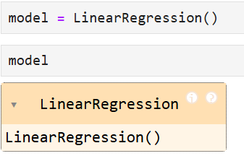

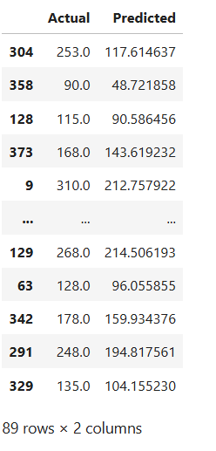
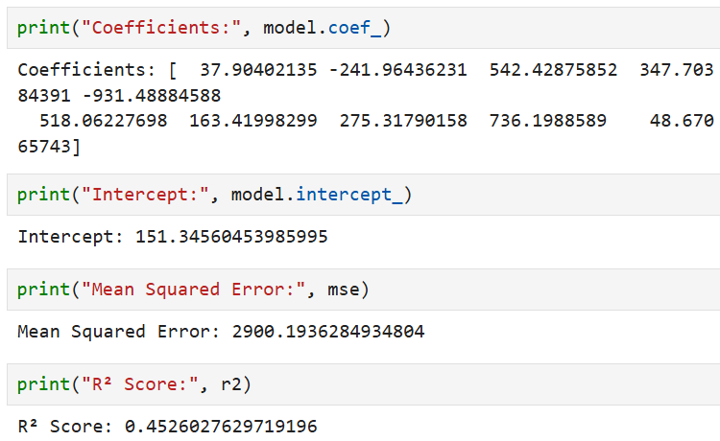

***************************************************************************
PROGRAM 2: Logistic Regression for the breast cancer dataset
REGNO: 24251115
DATE: 23-05-2025
***************************************************************************
from sklearn.datasets import load_breast_cancer
from sklearn.linear_model import LogisticRegression
from sklearn.model_selection import train_test_split
from sklearn.metrics import classification_report, confusion_matrix, accuracy_score

# Load the dataset
cancer = load_breast_cancer()
X = cancer.data
y = cancer.target

# Split into train and test sets
X_train, X_test, y_train, y_test = train_test_split(X, y, test_size=0.2, random_state=42)

# Create and train the model
model = LogisticRegression(max_iter=10000) # max_iter increased to ensure convergence
model.fit(X_train, y_train)

# Make predictions
y_pred = model.predict(X_test)
comparison_df = pd.DataFrame(
{
'Actual': y_test,
'Predicted': y_pred
}
)
comparison_df

# Evaluate the model
print("Confusion Matrix:\n", confusion_matrix(y_test, y_pred))
print("\nClassification Report:\n", classification_report(y_test, y_pred))
print("Accuracy Score:", accuracy_score(y_test, y_pred))

OUTPUT:

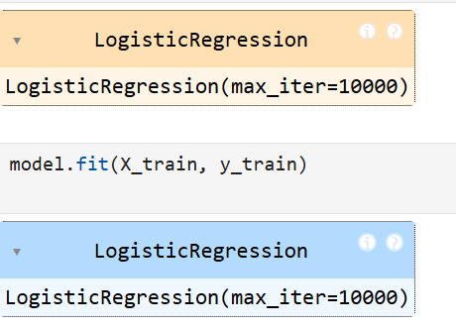
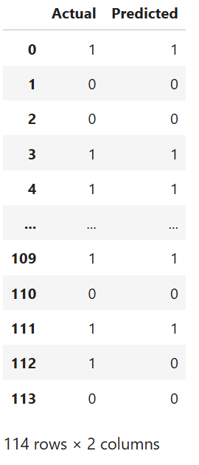
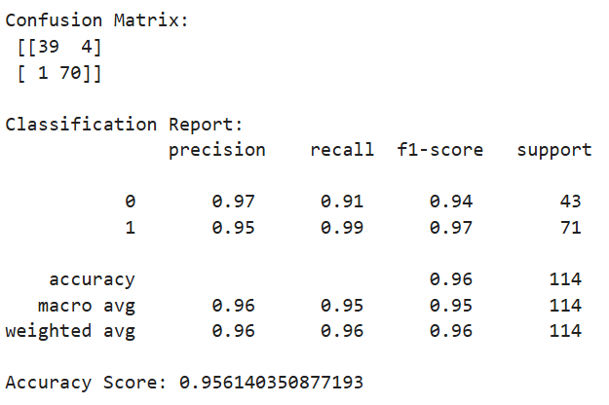

***************************************************************************
PROGRAM 3: Classification matrix for the Decision Tree classifier for iris dataset
REGNO:24251115
DATE: : 23-05-2025
*************************************************************************** sklearn.datasets import load_iris
from sklearn.tree import DecisionTreeClassifier
from sklearn.model_selection import train_test_split
from sklearn.metrics import confusion_matrix, classification_report, accuracy_score

# Load the iris dataset
iris = load_iris()
X = iris.data
y = iris.target

# Split into train and test sets
X_train, X_test, y_train, y_test = train_test_split(X, y, test_size=0.2, random_state=42)

# Create and train Decision Tree classifier
clf = DecisionTreeClassifier(random_state=42)
clf.fit(X_train, y_train)

# Predict on test data
y_pred = clf.predict(X_test)

# Evaluate using confusion matrix
cm = confusion_matrix(y_test, y_pred)
report = classification_report(y_test, y_pred, target_names=iris.target_names)
accuracy = accuracy_score(y_test, y_pred)

# Output
print("Confusion Matrix:\n", cm)
print("\nClassification Report:\n", report)
print("Accuracy Score:", accuracy)
OUTPUT:
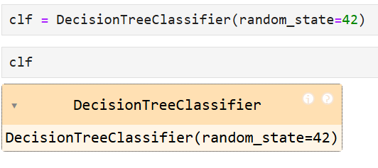
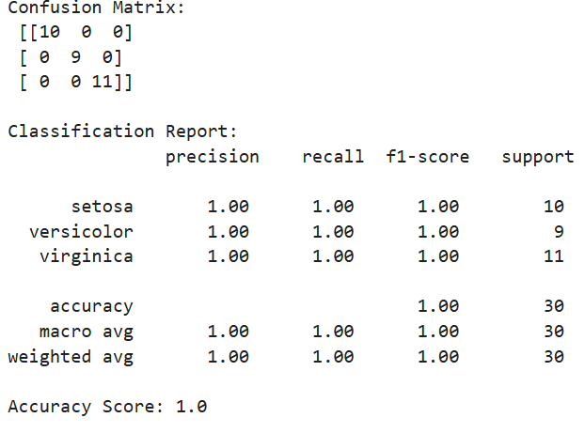

***************************************************************************
PROGRAM 4: Classification model for Wine dataset using RandomForestClassifier
REGNO: 24251115
DATE: : 23-05-2025
***************************************************************************
from sklearn.datasets import load_wine
from sklearn.ensemble import RandomForestClassifier
from sklearn.model_selection import train_test_split
from sklearn.metrics import accuracy_score, classification_report, confusion_matrix

# Load the dataset
wine = load_wine()
X = wine.data
y = wine.target

# Split the data into training and testing sets
X_train, X_test, y_train, y_test = train_test_split(X, y, test_size=0.2, random_state=42)

# Initialize the RandomForestClassifier
clf = RandomForestClassifier(n_estimators=100, random_state=42)

# Train the model
clf.fit(X_train, y_train)

# Make predictions
y_pred = clf.predict(X_test)

# Evaluate the model
accuracy = accuracy_score(y_test, y_pred)
report = classification_report(y_test, y_pred, target_names=wine.target_names)
conf_matrix = confusion_matrix(y_test, y_pred)

# Display results
print("Accuracy:", accuracy)
print("Classification Report:\n", report)
print("Confusion Matrix:\n", conf_matrix)
OUTPUT:
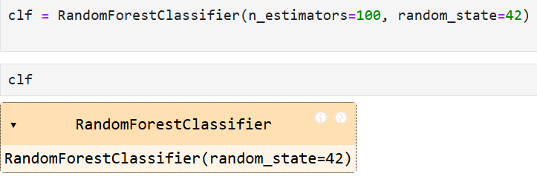
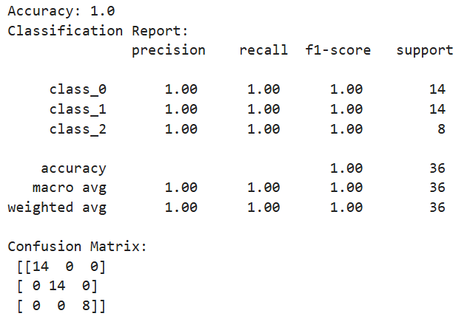

***************************************************************************
PROGRAM 5: Classification model for Wine dataset using K-Nearest Neighbors Classifier.
REGNO: 24251115
DATE: : 23-05-2025
***************************************************************************
# Import necessary libraries
from sklearn.datasets import load_wine
from sklearn.model_selection import train_test_split
from sklearn.preprocessing import StandardScaler
from sklearn.neighbors import KNeighborsClassifier
from sklearn.metrics import classification_report, accuracy_score, confusion_matrix

# Step 1: Load the dataset
wine = load_wine()
X = wine.data
y = wine.target

# Step 2: Split the dataset into training and testing sets
X_train, X_test, y_train, y_test = train_test_split(X, y, test_size=0.2, random_state=42)

# Step 3: Standardize the features
scaler = StandardScaler()
X_train_scaled = scaler.fit_transform(X_train)
X_test_scaled = scaler.transform(X_test)

# Step 4: Create and train the KNN model
knn = KNeighborsClassifier(n_neighbors=5)
knn.fit(X_train_scaled, y_train)

# Step 5: Make predictions
y_pred = knn.predict(X_test_scaled)

# Step 6: Evaluate the model
print("Confusion Matrix:")
print(confusion_matrix(y_test, y_pred))

print("\nClassification Report:")
print(classification_report(y_test, y_pred))

print("Accuracy Score:", accuracy_score(y_test, y_pred))

OUTPUT:
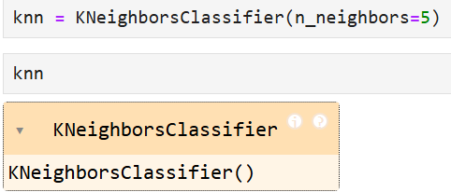
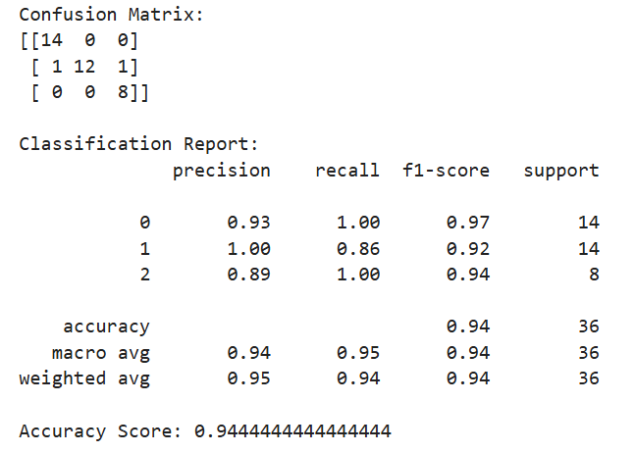

**************************************************************************
PROGRAM 6: Regression model for Fetch House Pricing using RandomForestRegressor
REGNO: 24251115
DATE: : 23-05-2025
**************************************************************************
import matplotlib.pyplot as plt
from sklearn.datasets import fetch_california_housing
from sklearn.model_selection import train_test_split
from sklearn.preprocessing import StandardScaler
from sklearn.ensemble import RandomForestRegressor
from sklearn.metrics import mean_squared_error, r2_score

# Step 1: Load the dataset
housing = fetch_california_housing()
X = housing.data
y = housing.target

# Step 2: Split into training and testing data
X_train, X_test, y_train, y_test = train_test_split(X, y, test_size=0.2, random_state=42)

# Step 3: Standardize the data
scaler = StandardScaler()
X_train_scaled = scaler.fit_transform(X_train)
X_test_scaled = scaler.transform(X_test)

# Step 4: Train the Random Forest Regressor
model = RandomForestRegressor(n_estimators=100, random_state=42)
model.fit(X_train_scaled, y_train)

# Step 5: Predict
y_pred = model.predict(X_test_scaled)

# Step 6: Evaluate the model
mse = mean_squared_error(y_test, y_pred)
r2 = r2_score(y_test, y_pred)

print("Mean Squared Error:", round(mse, 4))
print("R-squared Score:", round(r2, 4))

# Step 7: Plot actual vs predicted values
plt.scatter(y_test, y_pred, alpha=0.5, color='green')
plt.xlabel("Actual House Prices")
plt.ylabel("Predicted House Prices")
plt.title("Actual vs. Predicted House Prices")
plt.grid(True)
plt.plot([min(y_test), max(y_test)], [min(y_test), max(y_test)], 'r--') # Diagonal line
plt.show()

OUTPUT:
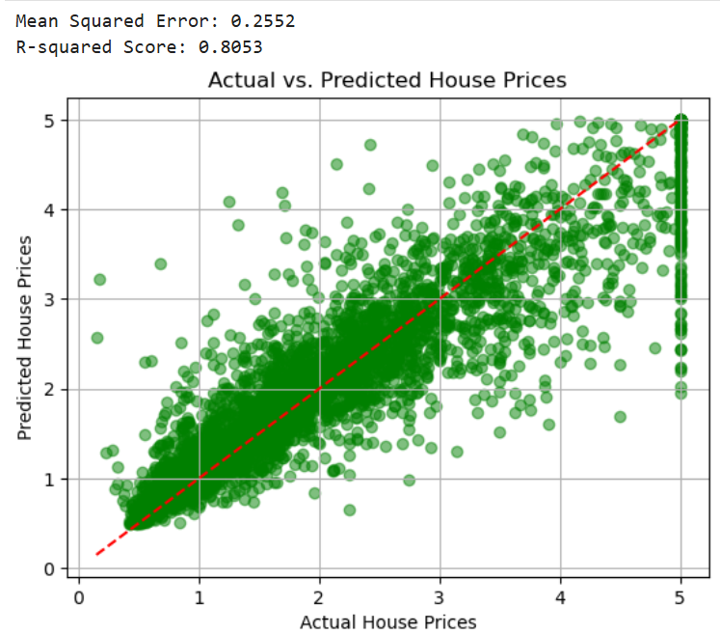

***************************************************************************
PROGRAM 7: Regression model for Fetch House Prizing using KneighborRegressor
REGNO: 24251115
DATE: 23-05-2025
**************************************************************************
import matplotlib.pyplot as plt
from sklearn.datasets import fetch_california_housing
from sklearn.model_selection import train_test_split
from sklearn.preprocessing import StandardScaler
from sklearn.neighbors import KNeighborsRegressor
from sklearn.metrics import mean_squared_error, r2_score

# Step 1: Load the dataset
housing = fetch_california_housing()
X = housing.data
y = housing.target

# Step 2: Split into training and testing data
X_train, X_test, y_train, y_test = train_test_split(X, y, test_size=0.2, random_state=42)

# Step 3: Standardize the data
scaler = StandardScaler()
X_train_scaled = scaler.fit_transform(X_train)
X_test_scaled = scaler.transform(X_test)

# Step 4: Train the K-Nearest Neighbors Regressor
model = KNeighborsRegressor(n_neighbors=5)
model.fit(X_train_scaled, y_train)

# Step 5: Predict
y_pred = model.predict(X_test_scaled)

# Step 6: Evaluate the model
mse = mean_squared_error(y_test, y_pred)
r2 = r2_score(y_test, y_pred)

print("Mean Squared Error:", round(mse, 4))
print("R-squared Score:", round(r2, 4))

# Step 7: Plot actual vs predicted values
plt.scatter(y_test, y_pred, alpha=0.5, color='blue')
plt.xlabel("Actual House Prices")
plt.ylabel("Predicted House Prices")
plt.title("Actual vs. Predicted House Prices (KNN)")
plt.plot([min(y_test), max(y_test)], [min(y_test), max(y_test)], 'r--') # Diagonal line
plt.grid(True)
plt.show()

OUTPUT:
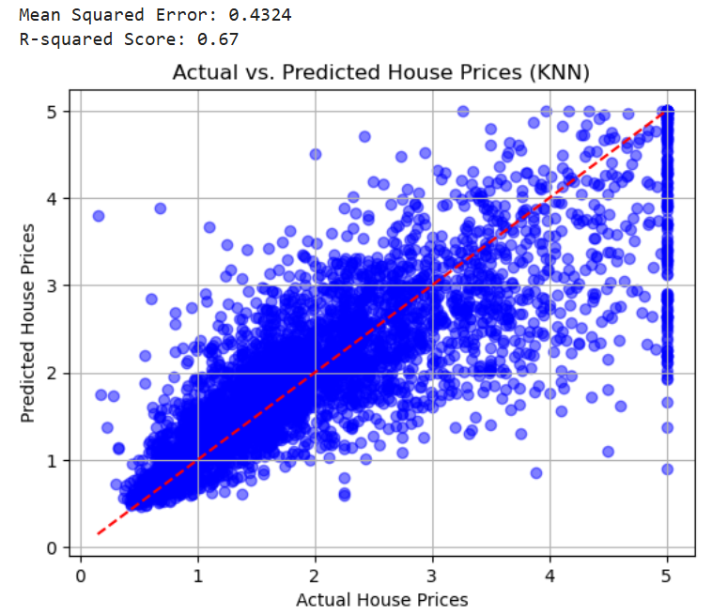

***************************************************************************
PROGRAM 8: Preprocessing missing value treatment
REGNO: 24251115
DATE: 23-05-2025
***************************************************************************
import matplotlib.pyplot 8. Preprocessing missing value treatment
import pandas as pd
from sklearn.impute import SimpleImputer
from sklearn.linear_model import LinearRegression
from sklearn.model_selection import train_test_split
from sklearn.metrics import mean_squared_error

# Sample data with missing values
data = {
'Age': [25, 30, None, 35, 40],
'Salary': [50000, 60000, 52000, None, 58000],
'HousePrice': [200000, 250000, 220000, 240000, 230000]
}

df = pd.DataFrame(data)

# Separate features and target
X = df[['Age', 'Salary']]
y = df['HousePrice']

# Fill missing values with mean
imputer = SimpleImputer(strategy='mean')
X = imputer.fit_transform(X)

# Train-test split
X_train, X_test, y_train, y_test = train_test_split(X, y, test_size=0.2, random_state=42)

# Train linear regression model
model = LinearRegression()
model.fit(X_train, y_train)

# Predict and evaluate
y_pred = model.predict(X_test)
mse = mean_squared_error(y_test, y_pred)

print("Mean Squared Error:", round(mse, 2))

OUTPUT:
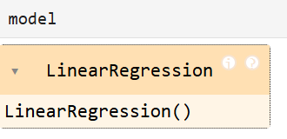
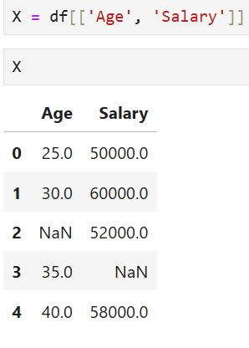
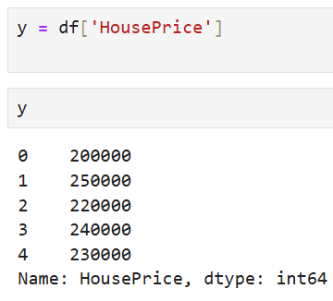

***************************************************************************
PROGRAM 9: Preprocessing, Scaling and Encoding
REGNO: 24251115
DATE: 23-05-2025
***************************************************************************
import pandas as pd
from sklearn.impute import SimpleImputer
from sklearn.preprocessing import StandardScaler
from sklearn.model_selection import train_test_split
from sklearn.linear_model import LinearRegression
from sklearn.metrics import mean_squared_error, r2_score

data = {
'Age': [25, 30, None, 35, 40],
'Salary': [50000, 60000, 52000, None, 58000],
'City': ['New York', 'Paris', 'London', None, 'Paris'],
'HousePrice': [200000, 250000, 220000, 240000, 230000]
}

df = pd.DataFrame(data)
X = df.drop('HousePrice', axis=1)
y = df['HousePrice']

# Missing value treatment
num_cols = ['Age', 'Salary']
cat_cols = ['City']

imputer_num = SimpleImputer(strategy='mean')
X[num_cols] = imputer_num.fit_transform(X[num_cols])

imputer_cat = SimpleImputer(strategy='most_frequent')
X[cat_cols] = imputer_cat.fit_transform(X[cat_cols])

# Encoding categorical variables
X = pd.get_dummies(X, drop_first=True)

# Scaling numeric features
scaler = StandardScaler()
X[num_cols] = scaler.fit_transform(X[num_cols])

# Split data
X_train, X_test, y_train, y_test = train_test_split(X, y, test_size=0.2, random_state=42)

# Train model
model = LinearRegression()
model.fit(X_train, y_train)

# Predict and evaluate
y_pred = model.predict(X_test)
mse = mean_squared_error(y_test, y_pred)
r2 = r2_score(y_test, y_pred)

print(f"Mean Squared Error: {mse:.2f}")
print(f"R-squared Score: {r2:.2f}")

OUTPUT
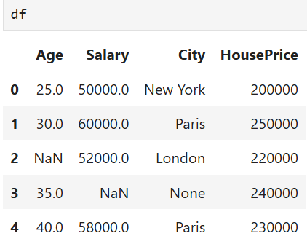
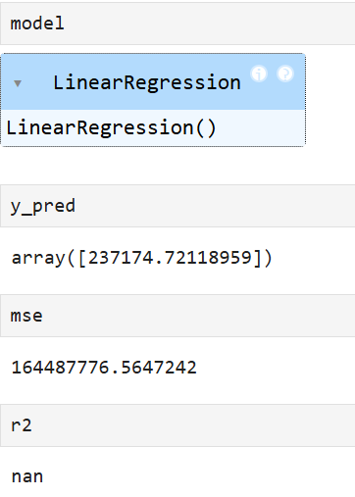

***************************************************************************
PROGRAM 10: SVM model with preprocessing for the Gender classification dataset
REGNO: 24251115
DATE: 23-05-2025
***************************************************************************
import pandas as pd
from sklearn.model_selection import train_test_split
from sklearn.preprocessing import StandardScaler, LabelEncoder
from sklearn.svm import SVC
from sklearn.metrics import confusion_matrix, accuracy_score, classification_report
import matplotlib.pyplot as plt
import seaborn as sns

# Sample dataset
data = {
'Height': [170, 160, 180, 175, 155, 165, 172, 158],
'Weight': [65, 55, 80, 70, 50, 60, 68, 54],
'Age': [25, 22, 28, 30, 20, 27, 24, 21],
'Gender': ['Male', 'Female', 'Male', 'Male', 'Female', 'Female', 'Male', 'Female']
}

df = pd.DataFrame(data)

# Features and target
X = df.drop('Gender', axis=1)
y = df['Gender']

# Encode target
label_encoder = LabelEncoder()
y_encoded = label_encoder.fit_transform(y) # Male=1, Female=0 or vice versa

# Scale features
scaler = StandardScaler()
X_scaled = scaler.fit_transform(X)

# Split data
X_train, X_test, y_train, y_test = train_test_split(X_scaled, y_encoded, test_size=0.25, random_state=42)

# Train SVM
svm_model = SVC(kernel='linear', random_state=42)
svm_model.fit(X_train, y_train)

# Predict
y_pred = svm_model.predict(X_test)

# Evaluate
acc = accuracy_score(y_test, y_pred)
print(f"Accuracy: {acc:.2f}")
print(classification_report(y_test, y_pred, target_names=label_encoder.classes_))

# Confusion Matrix
cm = confusion_matrix(y_test, y_pred)

# Plot confusion matrix
plt.figure(figsize=(6,4))
sns.heatmap(cm, annot=True, fmt='d', cmap='Blues',
xticklabels=label_encoder.classes_,
yticklabels=label_encoder.classes_)
plt.xlabel('Predicted')
plt.ylabel('Actual')
plt.title('Confusion Matrix - Gender Classification')
plt.show()

OUTPUT:
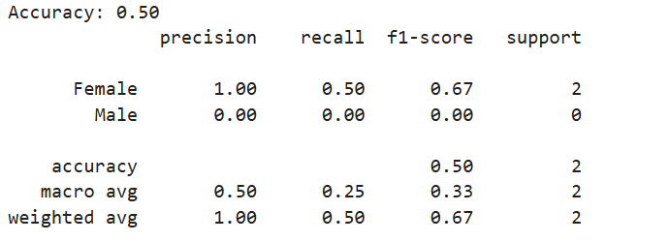

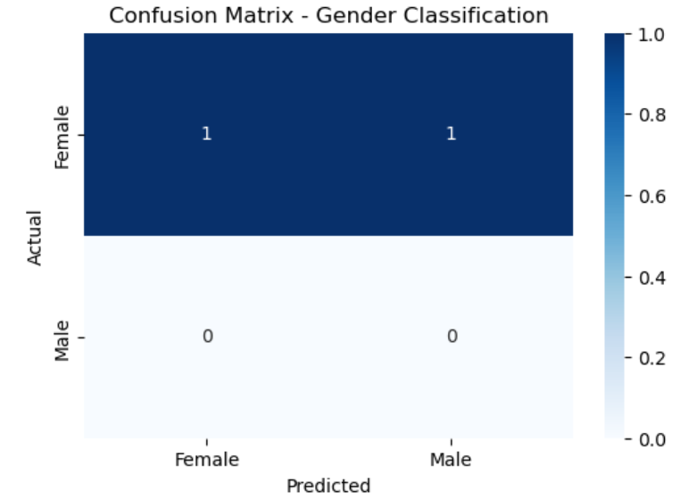

***************************************************************************
PROGRAM 11: Gradient boosting classification with preprocessing for the Student Marks Dataset
REGNO: 24251115
DATE: : 23-05-2025
***************************************************************************
import pandas as pd
from sklearn.model_selection import train_test_split
from sklearn.impute import SimpleImputer
from sklearn.preprocessing import StandardScaler, LabelEncoder
from sklearn.ensemble import GradientBoostingClassifier
from sklearn.metrics import accuracy_score, confusion_matrix
import matplotlib.pyplot as plt
import seaborn as sns

# 1. Sample data
data = {
'Math': [85, 70, 90, None, 60],
'Science': [90, 65, None, 80, 70],
'English': [78, 80, 85, 75, None],
'Gender': ['Male', 'Female', 'Male', 'Female', 'Female'],
'Passed': ['Yes', 'No', 'Yes', 'No', 'No']
}

df = pd.DataFrame(data)

# 2. Separate features and target
X = df.drop('Passed', axis=1)
y = df['Passed']

# 3. Fill missing numeric values with mean
imputer = SimpleImputer(strategy='mean')
X[['Math', 'Science', 'English']] = imputer.fit_transform(X[['Math', 'Science', 'English']])

# 4. Encode Gender column
X = pd.get_dummies(X, columns=['Gender'], drop_first=True)

# 5. Scale numeric columns
scaler = StandardScaler()
X[['Math', 'Science', 'English']] = scaler.fit_transform(X[['Math', 'Science', 'English']])

# 6. Encode target variable
le = LabelEncoder()
y = le.fit_transform(y) # Yes=1, No=0

# 7. Split dataset
X_train, X_test, y_train, y_test = train_test_split(X, y, test_size=0.2, random_state=42)

# 8. Train Gradient Boosting Classifier
model = GradientBoostingClassifier(random_state=42)
model.fit(X_train, y_train)

# 9. Predict and evaluate
y_pred = model.predict(X_test)
accuracy = accuracy_score(y_test, y_pred)
print("Accuracy:", round(accuracy, 2))

# 10. Confusion matrix
cm = confusion_matrix(y_test, y_pred)

# 11. Plot confusion matrix
plt.figure(figsize=(5,4))
sns.heatmap(cm, annot=True, fmt='d', cmap='Blues',
xticklabels=le.classes_, yticklabels=le.classes_)
plt.xlabel('Predicted')
plt.ylabel('Actual')
plt.title('Confusion Matrix - Student Marks')
plt.show()

OUTPUT:
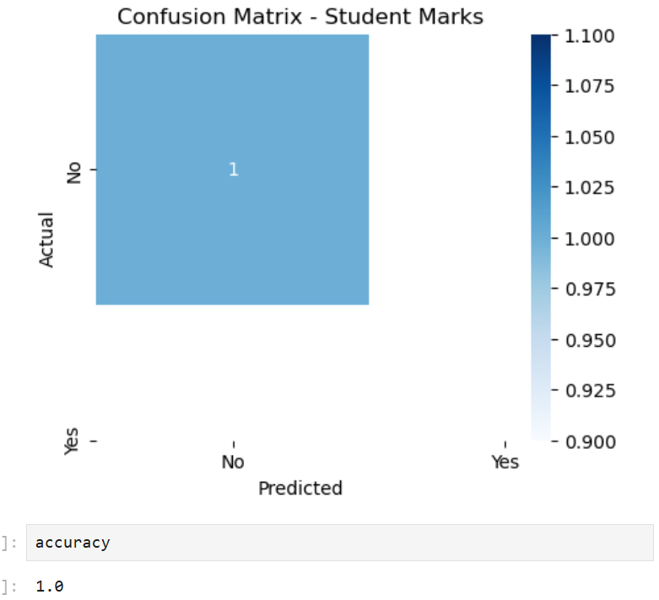

***************************************************************************
PROGRAM 12: . Visualization using matplotlib for iris dataset
- Bar chart
- Pie chart
- Histogram
REGNO: 24251115
DATE: : 23-05-2025
***************************************************************************
import matplotlib.pyplot as plt
from sklearn.datasets import load_iris

# Load Iris dataset
iris = load_iris()
target = iris.target
target_names = iris.target_names

# Count samples per species
counts = [sum(target == i) for i in range(len(target_names))]

# 1. Bar chart
plt.bar(target_names, counts)
plt.title('Samples per Iris Species')
plt.xlabel('Species')
plt.ylabel('Count')
plt.show()

# 2. Pie chart
plt.pie(counts, labels=target_names, autopct='%1.1f%%')
plt.title('Species Distribution')
plt.show()

# 3. Histogram (Sepal Length)
plt.hist(iris.data[:, 0], bins=15)
plt.title('Sepal Length Distribution')
plt.xlabel('Sepal Length (cm)')
plt.ylabel('Frequency')
plt.show()

OUTPUT:
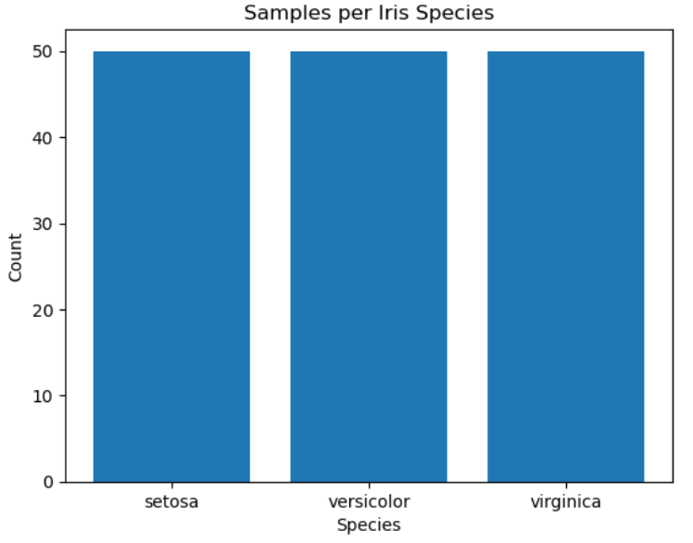
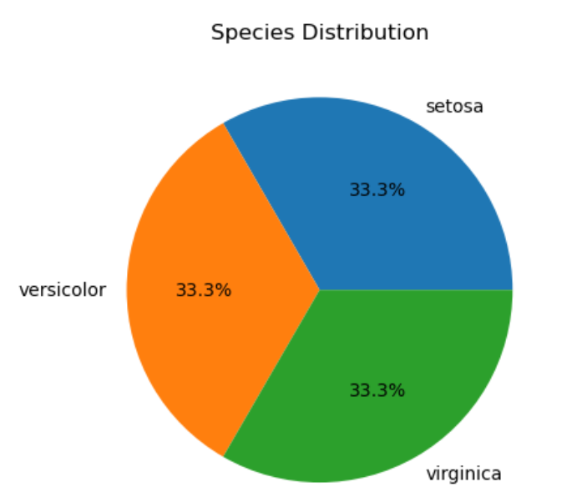
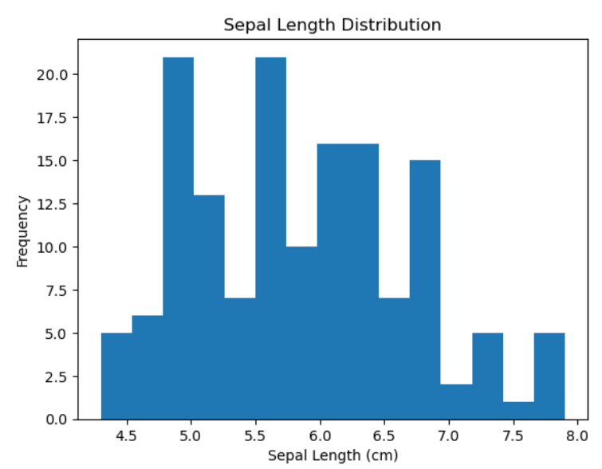

***************************************************************************
PROGRAM 13: Pickle File for digits dataset with GausianNB model
REGNO: 24251115
DATE: 23-05-2025
***************************************************************************
from sklearn.datasets import load_digits
from sklearn.model_selection import train_test_split
from sklearn.naive_bayes import GaussianNB
from sklearn.metrics import accuracy_score, confusion_matrix, ConfusionMatrixDisplay
import matplotlib.pyplot as plt

# 1. Load digits dataset
digits = load_digits()
X = digits.data
y = digits.target

# 2. Split data
X_train, X_test, y_train, y_test = train_test_split(X, y, test_size=0.2, random_state=42)

# 3. Train Gaussian Naive Bayes model
model = GaussianNB()
model.fit(X_train, y_train)

# 4. Predict and evaluate
y_pred = model.predict(X_test)
accuracy = accuracy_score(y_test, y_pred)
print(f"Accuracy: {accuracy:.2f}")

# 5. Confusion matrix plot
cm = confusion_matrix(y_test, y_pred)
disp = ConfusionMatrixDisplay(confusion_matrix=cm, display_labels=digits.target_names)
disp.plot(cmap=plt.cm.Blues)
plt.title("Confusion Matrix - GaussianNB on Digits Dataset")
plt.show()

# 6. Save model to pickle file
with open('gaussian_nb_digits.pkl', 'wb') as f:
pickle.dump(model, f)
print("Model saved to 'gaussian_nb_digits.pkl'")

# 7. Load the model (example)
with open('gaussian_nb_digits.pkl', 'rb') as f:
loaded_model = pickle.load(f)

# 8. Predict using loaded model (example)
sample_preds = loaded_model.predict(X_test[:5])
print("Sample predictions from loaded model:", sample_preds)

OUTPUT:
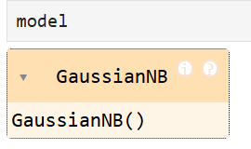

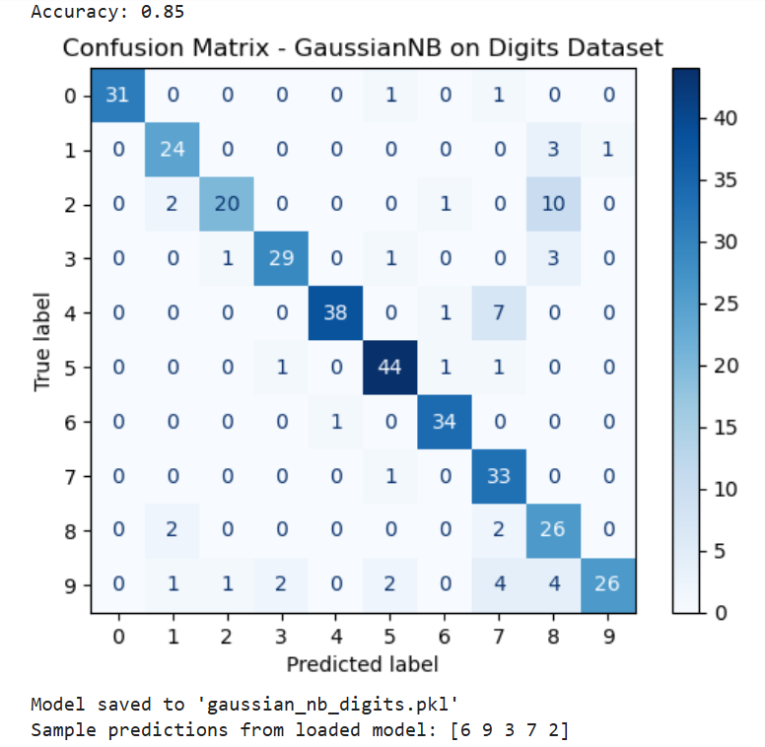

***************************************************************************
PROGRAM 14: Advanced visualization and interpretation using seaborn for titanic dataset
- Stacked bar chart
- KDE plot
- Violin plot
- Heatmap
- Swarm plot
REGNO: 24251115
DATE: 23-05-2025
***************************************************************************
Import matplotlib.pyplot as plt

# Load dataset
titanic = sns.load_dataset('titanic')

# 1. Stacked Bar Chart (using pandas plot)
survival = titanic.groupby(['class', 'sex'])['survived'].mean().unstack()
survival.plot(kind='bar', stacked=True, color=['pink', 'lightblue'])
plt.title('Survival Rate by Class and Sex')
plt.ylabel('Survival Rate')
plt.show()

# 2. KDE Plot for Age by Survival
sns.kdeplot(data=titanic, x='age', hue='survived', fill=True)
plt.title('Age Distribution by Survival')
plt.show()

# 3. Violin Plot for Age by Class
sns.violinplot(x='class', y='age', data=titanic)
plt.title('Age Distribution by Class')
plt.show()

# 4. Heatmap for Correlation
numeric_data = titanic.select_dtypes(include=['float64', 'int64'])
sns.heatmap(numeric_data.corr(), annot=True, cmap='coolwarm')
plt.title('Correlation Heatmap')
plt.show()

# 5. Swarm Plot for Fare by Survival
sns.swarmplot(x='survived', y='fare', data=titanic)
plt.title('Fare Paid by Survival')
plt.show()

OUTPUT:
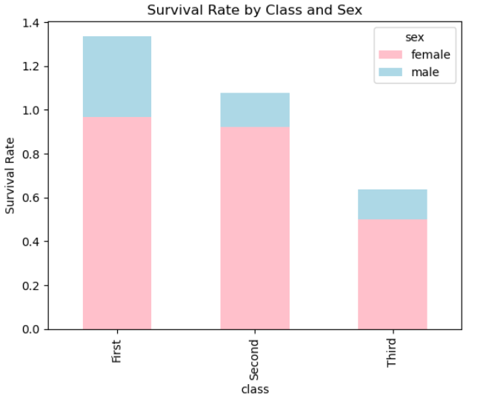
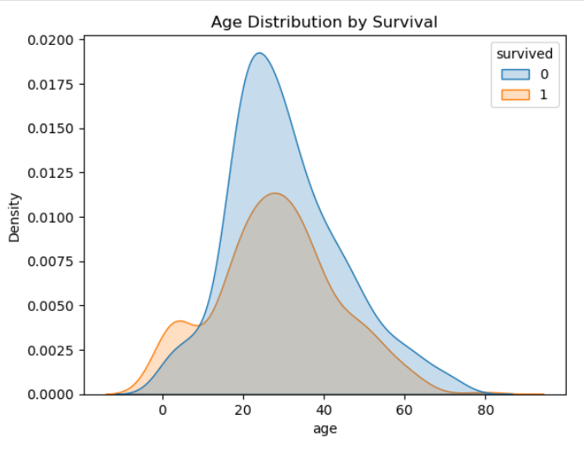
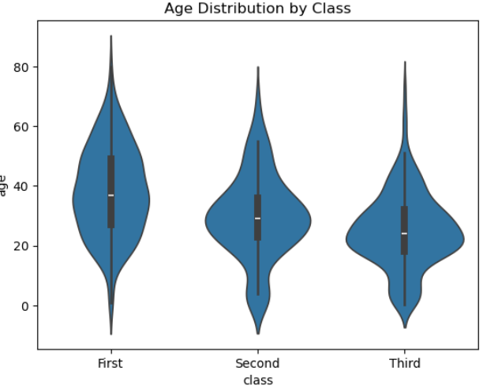
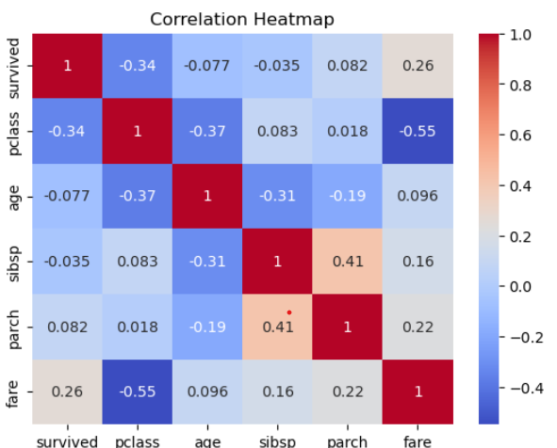
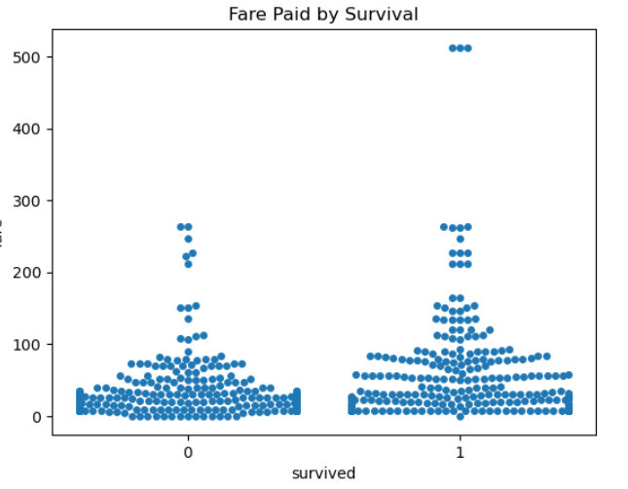

***************************************************************************
PROGRAM 15: KMeans Cluster analysis
REGNO: 24251115
DATE: 23-05-2025
***************************************************************************
import pandas as pd
import seaborn as sns
import matplotlib.pyplot as plt
from sklearn.cluster import KMeans
from sklearn.datasets import load_iris

# Load Iris dataset
iris = load_iris()
df = pd.DataFrame(iris.data, columns=iris.feature_names)

# Apply KMeans clustering
kmeans = KMeans(n_clusters=3, random_state=0)
df['cluster'] = kmeans.fit_predict(df)

# Add species for comparison (optional)
df['species'] = iris.target

# Plot clusters (using first two features for simplicity)
plt.figure(figsize=(7,5))
sns.scatterplot(x=df.iloc[:, 0], y=df.iloc[:, 1], hue=df['cluster'], palette='Set1')
plt.title('KMeans Clustering on Iris Dataset')
plt.xlabel(iris.feature_names[0])
plt.ylabel(iris.feature_names[1])
plt.show()

OUTPUT:
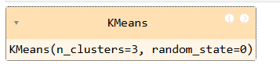

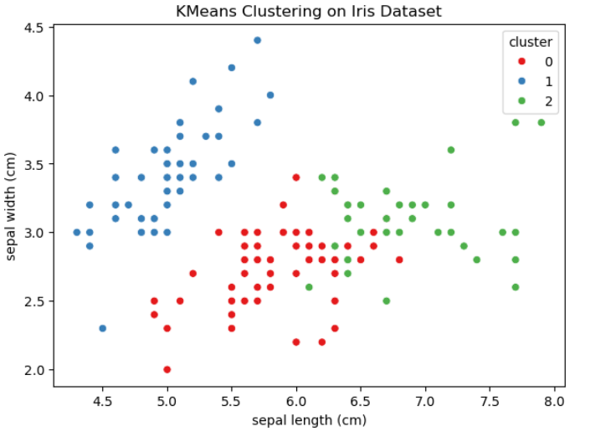

***************************************************************************
PROGRAM 16: . Program to build a machine learning model to predict whether the person is diabetic or not using Bagging Classifier
REGNO:24251115
DATE: 23-05-2025
**************************************************************************
import pandas as pd
from sklearn.datasets import load_diabetes
from sklearn.model_selection import train_test_split
from sklearn.preprocessing import StandardScaler
from sklearn.ensemble import BaggingClassifier
from sklearn.tree import DecisionTreeClassifier
from sklearn.metrics import accuracy_score, confusion_matrix, mean_squared_error, r2_score
import seaborn as sns
import matplotlib.pyplot as plt

# Load dataset
data = load_diabetes()
X = pd.DataFrame(data.data, columns=data.feature_names)

# Convert target to binary classification (1 = diabetic, 0 = not)
y = (data.target > data.target.mean()).astype(int)

# Split dataset
X_train, X_test, y_train, y_test = train_test_split(X, y, test_size=0.2, random_state=42)

# Scale features
scaler = StandardScaler()
X_train_scaled = scaler.fit_transform(X_train)
X_test_scaled = scaler.transform(X_test)

# Train Bagging Classifier
model = BaggingClassifier(estimator=DecisionTreeClassifier(), n_estimators=50, random_state=42)
model.fit(X_train_scaled, y_train)

# Predict
y_pred = model.predict(X_test_scaled)

# --- Metrics ---
accuracy = accuracy_score(y_test, y_pred)
mse = mean_squared_error(y_test, y_pred)
r2 = r2_score(y_test, y_pred)
cm = confusion_matrix(y_test, y_pred)

# --- Print Metrics ---
print("Accuracy:", round(accuracy, 4))
print("Mean Squared Error:", round(mse, 4))
print("R-squared Score:", round(r2, 4))

# --- Plot Confusion Matrix ---
sns.heatmap(cm, annot=True, fmt='d', cmap='Blues',
xticklabels=['Not Diabetic', 'Diabetic'],
yticklabels=['Not Diabetic', 'Diabetic'])
plt.title("Confusion Matrix")
plt.xlabel("Predicted")
plt.ylabel("Actual")
plt.show()

OUTPUT:
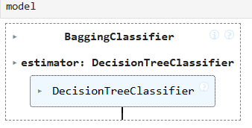
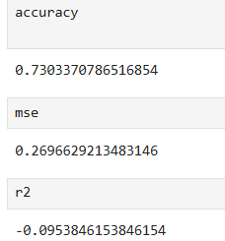
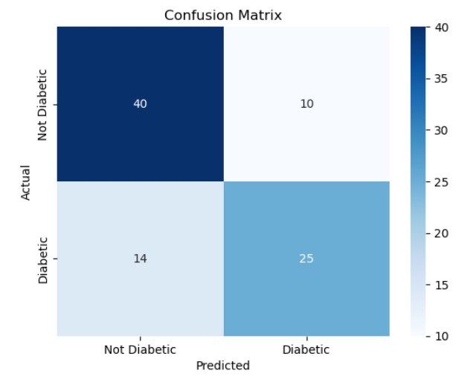

***************************************************************************
PROGRAM 17: Program to demonstrate Principal Component Analysis(PCA)
REGNO:24251115
DATE: 23-05-2025
***************************************************************************
import pandas as pd
import matplotlib.pyplot as plt
from sklearn.datasets import load_iris
from sklearn.preprocessing import StandardScaler
from sklearn.decomposition import PCA

# Step 1: Load the Iris dataset
iris = load_iris()
X = iris.data # Features (sepal & petal measurements)
y = iris.target # Target (species)
target_names = iris.target_names

# Step 2: Standardize the data
scaler = StandardScaler()
X_scaled = scaler.fit_transform(X)

# Step 3: Apply PCA to reduce dimensions (from 4 to 2)
pca = PCA(n_components=2)
X_pca = pca.fit_transform(X_scaled)

# Step 4: Create a DataFrame for PCA results
pca_df = pd.DataFrame(X_pca, columns=['PC1', 'PC2'])
pca_df['Species'] = y

# Step 5: Plot the 2 principal components
plt.figure(figsize=(7, 5))
for i, label in enumerate(target_names):
plt.scatter(pca_df[pca_df['Species'] == i]['PC1'],
pca_df[pca_df['Species'] == i]['PC2'],
label=label)

plt.title('PCA of Iris Dataset')
plt.xlabel('Principal Component 1')
plt.ylabel('Principal Component 2')
plt.legend()
plt.grid(True)
plt.show()Program to demonstrate Principal Component Analysis(PCA)

OUTPUT:
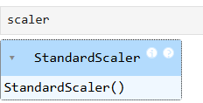
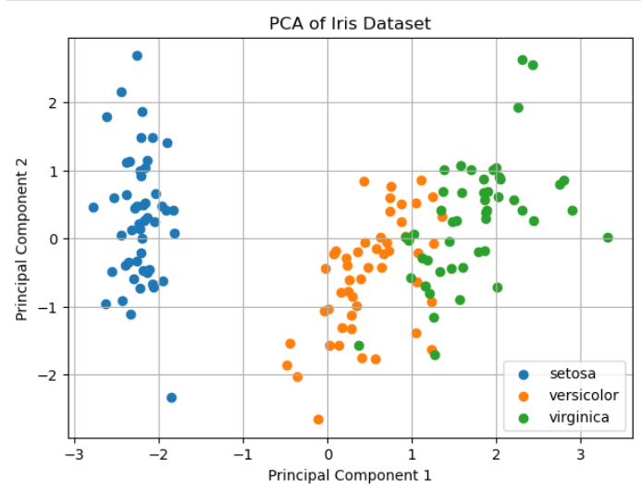

**************************************************************************
PROGRAM 18: .Program to demonstrate K Nearest Neighbours Classification(KNN).
REGNO:24251102
DATE: 23-05-2025
**************************************************************************
import pandas as pd
import matplotlib.pyplot as plt
from sklearn.datasets import load_iris
from sklearn.model_selection import train_test_split
from sklearn.preprocessing import StandardScaler
from sklearn.neighbors import KNeighborsClassifier
from sklearn.metrics import accuracy_score, confusion_matrix, mean_squared_error
import seaborn as sns

# Load Iris dataset
iris = load_iris()
X = iris.data
y = iris.target
target_names = iris.target_names

# Split dataset
X_train, X_test, y_train, y_test = train_test_split(X, y, test_size=0.2, random_state=42)

# Scale features
scaler = StandardScaler()
X_train_scaled = scaler.fit_transform(X_train)
X_test_scaled = scaler.transform(X_test)

# Train KNN model
knn = KNeighborsClassifier(n_neighbors=3)
knn.fit(X_train_scaled, y_train)

# Predict
y_pred = knn.predict(X_test_scaled)

# Evaluate
accuracy = accuracy_score(y_test, y_pred)
mse = mean_squared_error(y_test, y_pred)

print(f"Accuracy: {accuracy:.4f}")
print(f"Mean Squared Error: {mse:.4f}")

# Confusion matrix plot
cm = confusion_matrix(y_test, y_pred)
plt.figure(figsize=(6, 4))
sns.heatmap(cm, annot=True, fmt="d", cmap="Blues",
xticklabels=target_names, yticklabels=target_names)
plt.title("Confusion Matrix - KNN")
plt.xlabel("Predicted")
plt.ylabel("Actual")
plt.show()

OUTPUT:
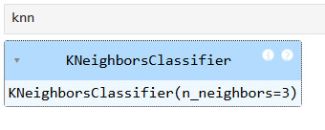
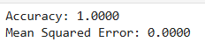
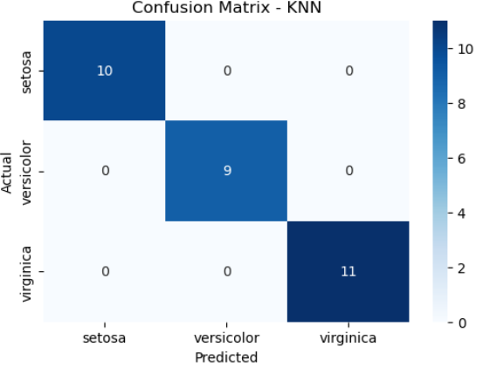

***************************************************************************
PROGRAM 19: Program to demonstrate Neural Networks and deep Learning
REGNO: 24251115
DATE: 23-05-2025
***************************************************************************
from sklearn.datasets import load_iris
from sklearn.model_selection import train_test_split
from sklearn.preprocessing import StandardScaler
from sklearn.neural_network import MLPClassifier
from sklearn.metrics import accuracy_score, confusion_matrix
import seaborn as sns
import matplotlib.pyplot as plt

# 1. Load data
iris = load_iris()
X = iris.data
y = iris.target

# 2. Scale features
scaler = StandardScaler()
X_scaled = scaler.fit_transform(X)

# 3. Split data
X_train, X_test, y_train, y_test = train_test_split(X_scaled, y, test_size=0.2, random_state=42)

# 4. Build and train the MLP neural network
mlp = MLPClassifier(hidden_layer_sizes=(10,), max_iter=500, random_state=42)
mlp.fit(X_train, y_train)

# 5. Predict
y_pred = mlp.predict(X_test)

# 6. Accuracy
acc = accuracy_score(y_test, y_pred)
print(f"Test accuracy: {acc:.4f}")

# 7. Confusion matrix
cm = confusion_matrix(y_test, y_pred)
sns.heatmap(cm, annot=True, fmt='d', cmap='Blues',
xticklabels=iris.target_names, yticklabels=iris.target_names)
plt.xlabel('Predicted')
plt.ylabel('Actual')
plt.title('Confusion Matrix')
plt.show()

OUTPUT:
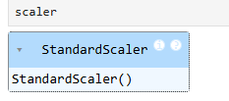
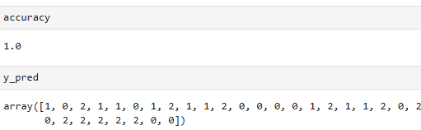
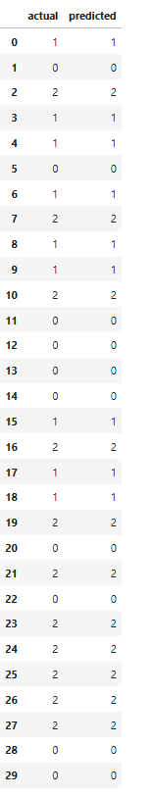

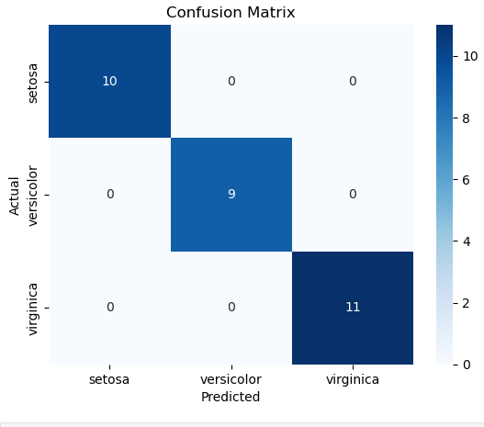
***************************************************************************
PROGRAM 20: . Visualization using matplotlib for iris dataset
- Scatter plot
- Box plot
- Line chart
REGNO: 24251115
DATE: 23-05-2025
***************************************************************************
import matplotlib.pyplot as plt
from sklearn.datasets import load_iris
import pandas as pd

# Load Iris dataset
iris = load_iris()
df = pd.DataFrame(data=iris.data, columns=iris.feature_names)
df['species'] = pd.Categorical.from_codes(iris.target, iris.target_names)

# 1. Scatter plot: Sepal Length vs Sepal Width colored by species
plt.figure(figsize=(7,5))
for species in iris.target_names:
subset = df[df['species'] == species]
plt.scatter(subset['sepal length (cm)'], subset['sepal width (cm)'], label=species)
plt.xlabel('Sepal Length (cm)')
plt.ylabel('Sepal Width (cm)')
plt.title('Scatter Plot of Sepal Length vs Sepal Width')
plt.legend()
plt.show()

# 2. Box plot: Distribution of Petal Length by Species
plt.figure(figsize=(7,5))
df.boxplot(column='petal length (cm)', by='species')
plt.title('Box Plot of Petal Length by Species')
plt.suptitle('') # Removes default subtitle
plt.xlabel('Species')
plt.ylabel('Petal Length (cm)')
plt.show()

# 3. Line chart: Mean sepal length for each species
mean_sepal_length = df.groupby('species')['sepal length (cm)'].mean()
plt.figure(figsize=(7,5))
plt.plot(mean_sepal_length.index, mean_sepal_length.values, marker='o')
plt.title('Mean Sepal Length by Species')
plt.xlabel('Species')
plt.ylabel('Mean Sepal Length (cm)')
plt.grid(True)
plt.show()

OUTPUT:
